**FOR IMMEDIATE RELEASE**

**MEDIA CONTACTS:**

**Adaora Onyebeke**

[adaora@philharmonicsociety.org](mailto:adaora@philharmonicsociety.org)

**Marie-Songco Torres**

[marie@philharmonicsociety.org](mailto:marie@philharmonicsociety.org)

**POPULAR VIOLINIST & MEDIA PERSONALITY RAY CHEN RETURNS TO ORANGE COUNTY ACCOMPANIED BY PIANIST JULIO ELIZALDE**

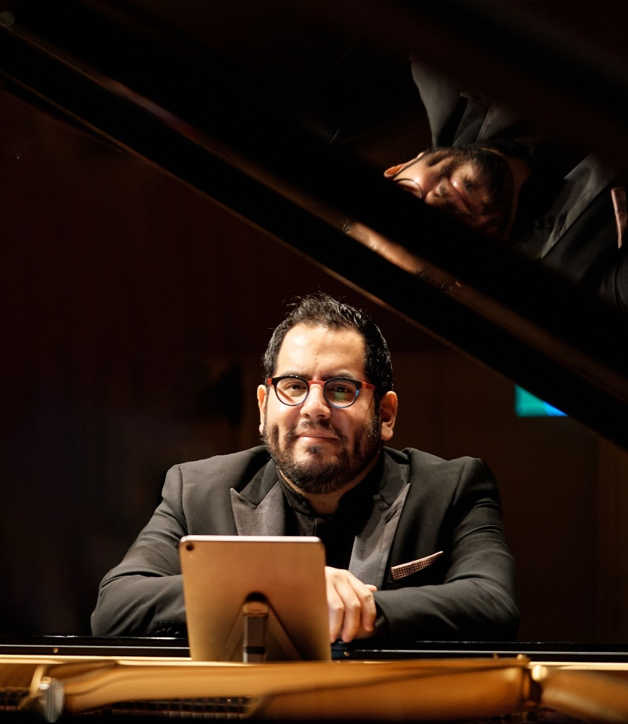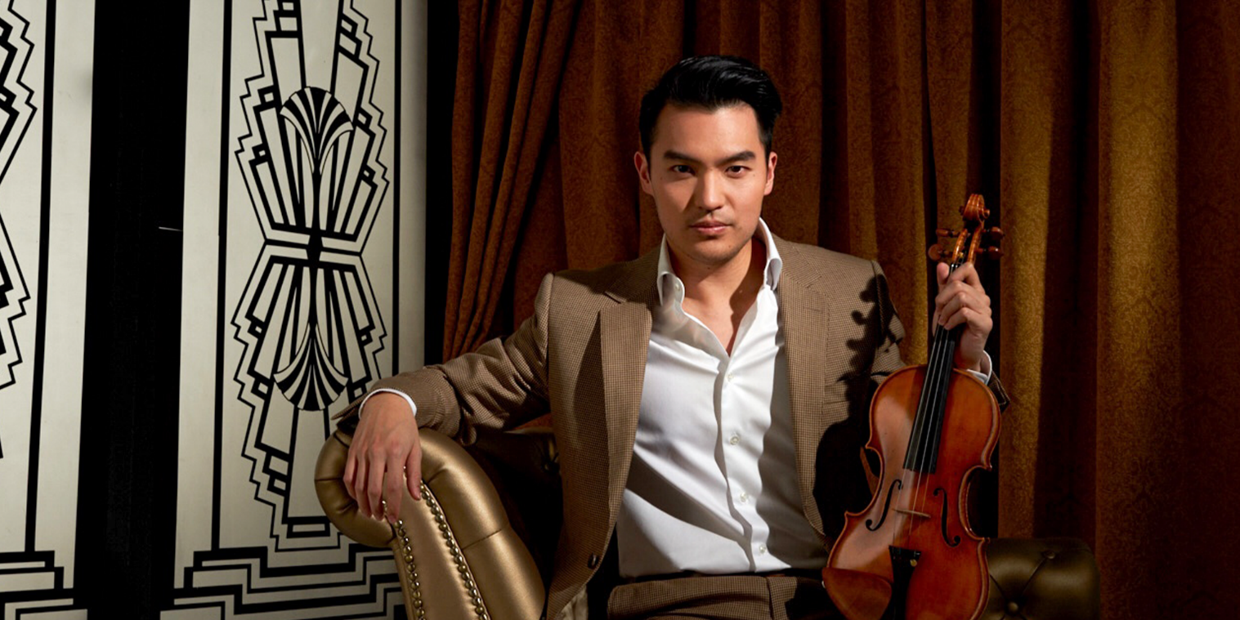

Photo: Dada Zheng

Photo: John Mac

**(IRVINE, CA, SEPTMEBER 6, 2024)**—Philharmonic Society of Orange County presents its first recital of the season with popular violinist and online media personality Ray Chen, along with multi-talented pianist Julio Elizalde, in recital on Sunday, October 27, 2024, at 3 pm at the Renée and Henry Segerstrom Concert Hall, Segerstrom Center for the Arts. This event presents a selection of popular works including Dvořák’s Slavonic Dance No. 2 in E minor, Beethoven’s Violin Sonata, and Bach’s Partita No.3.

**Ray Chen** redefines what it means to be a classical musician in the 21st century. With a global reach that enhances and inspires a new classical audience, Chen’s remarkable musicianship has transmitted to millions of people around the globe.

Chen’s presence on social media has made him a pioneer in classical artists’ use of modern technology to interact with their audiences. His appearances and interactions with music and musicians are instantly disseminated to a new public in a contemporary and relatable way. His commitment to music education is paramount and inspires the younger generation of music students with his series of self-produced videos combining comedy, education and music. Through his online promotions his appearances regularly sell out and draw an entirely new demographic to the concert hall.

Chen has taken his talents and popularity worldwide with appearances alongside the London Philharmonic Orchestra, National Symphony Orchestra, Leipzig Gewandhausorchester, Munich Philharmonic, Filarmonica della Scala, Orchestra Nazionale della Santa Cecilia, Los Angeles Philharmonic, SWR Symphony, New York Philharmonic, San Francisco Symphony, Pittsburgh Symphony, Berlin Radio Symphony, and Bavarian Radio Chamber Orchestra. He also works with conductors such as Riccardo Chailly, Vladimir Jurowski, Sakari Oramo, Manfred Honeck, Daniele Gatti, Kirill Petrenko, Krystof Urbanski, and Juraj Valcuha.

Praised as a musician of “compelling artistry and power” by *The Seattle Times*, the gifted

Hispanic-American pianist **Julio Elizalde** is a multifaceted artist who enjoys a unique career as

soloist, collaborator, curator, and educator. Julio has performed at many of the world’s major

music centers including Walt Disney Concert Hall (Los Angeles), Davies Symphony Hall (San

Francisco), Koerner Hall (Toronto), Alice Tully Hall (New York), Kioi Hall (Tokyo), Tokyo Opera City Concert Hall, Seoul Arts Center, Teatro Colón (Buenos Aires), St. Paul’s Knightsbridge (London), National Centre for the Performing Arts (Beijing), Shanghai Oriental Arts Center, Palacio de Bellas Artes (Mexico City), National Concert Hall (Taipei), and the Esplanade Concert Hall (Singapore), among many others.

For nearly a decade, he has appeared as a recital partner to famed violinists Ray Chen and Sarah Chang, and has collaborated with renowned artists such as Pablo Ferrández, Kian Soltani,

Pamela Frank, Robert McDonald, and members of the Juilliard, Cleveland, Takács, Kronos,

Brentano, St. Lawrence, and Dover string quartet. As a founding member of the N-E-W Trio

with violinist Andrew Wan and cellist Gal Nyska, he won the grand prize at the Fischoff National Chamber Music Competition and received the Harvard Musical Association’s prestigious Arthur

W. Foote Prize. As part of the Trio, he has performed for notable American politicians including

President Bill Clinton and Secretaries of State Condoleeza Rice and Henry Kissinger.

A champion of new music, Julio has collaborated with composers such as Osvaldo Golijov,

Stephen Hough, Adolphus Hailstork, and Michael Stephen Brown. In 2013, Julio was a featured

artist on the soundtrack composed by Academy Award-winner Howard Shore for the film *Jimmy P*, starring Benicio Del Toro.

Renée and Henry Segerstrom Concert Hall is located at 615 Town Center Drive, Costa Mesa, CA 92626. Ticket prices start at $28 and are available at the Philharmonic Society box office at (949) 553-2422, or online at www.philharmonicsociety.org.

**ABOUT THE PHILHARMONIC SOCIETY:**

Founded in 1954 as Orange County’s first music organization, the Philharmonic Society of Orange County presents national and international performances of the highest quality and provides dynamic and innovative music education programs for individuals of all ages to enhance the lives of Orange County audiences through music.

Since its inception, the Philharmonic Society has evolved and grown with the county’s changing landscape, presenting artists and orchestras who set the standard for artistic achievement from Itzhak Perlman, Gustavo Dudamel, Yo-Yo Ma, and Renée Fleming to the Berlin Philharmonic, Vienna Philharmonic, Chicago Symphony Orchestra, and many others. In addition, the Philharmonic Society celebrates multi-disciplinary performances under its Eclectic Orange brand and embraces music from a wide range of countries with its World Music performances. Its celebrated concerts introduce children to classical music with creative and inspiring performances, instilling music appreciation for future generations.

The Philharmonic Society’s nationally recognized Youth Music Education Programs, offered free of charge, engage more than 100,000 students annually through curriculum-based music education programs that aim to inspire, expand imaginations, and encourage learning at all levels. These programs are made possible by the Committees of the Philharmonic Society comprised of 500 volunteer members who provide more than 90,000 hours of in-kind service each year. As a key youth program, the exceptional Orange County Youth Symphony and String Ensemble provide top-tier training to the area’s most talented young musicians through multi-level ensemble instruction, leadership training, touring opportunities, challenging professional repertoire, and performances in world-class venues. The Philharmonic Society also promotes life-long learning by connecting with colleges and universities to conduct masterclasses and workshops and providing pre-concert lectures to introduce audiences to program selections.

**MEDIA CONTACTS :**

**MEDIA CONTACTS:**

**Adaora Onyebeke**

[adaora@philharmonicsociety.org](mailto:adaora@philharmonicsociety.org)

**Marie-Songco Torres**

[marie@philharmonicsociety.org](mailto:marie@philharmonicsociety.org)

**WHAT:** Ray Chen, violin

Julio Elizalde, piano

**WHEN:** Sunday, October 27, 2024, 3pm

With a 2pm pre**-**concert lecture hall

**PROGRAM:**  **TARTINI (arr. Kreisler):** Sonata in G minor *Devil’s Trill*

**BEETHOVEN:** Violin Sonata No. 7 in C minor, Op. 30, No. 2

**J.S. BACH:** Partita No. 3 in E major for Solo Violin, BWV 1006

**BAZZINI:** *La Ronde des Lutins*, Op. 25

**DVOŘÁK (arr. Kreisler):** Slavonic Dance No. 2 in E minor, Op. 72

**COREA (arr. Elizalde & Chen)**: *Spain*

**WHERE:** Renée & Henry Segerstrom Concert Hall, Segerstrom Center for the Arts

615 Town Center Drive, Costa Mesa, CA 92626

**TICKETS** Ticket prices start at $28.

Call for pricing and availability.

**AND**

**INFORMATION:** Available at the Philharmonic Society box office (949) 553-2422,

or online at [www.philharmonicsociety.org](http://www.philharmonicsociety.org).